TITLE ……………………

* First Name LAST NAME (SURNAME) ¹, First Name LAST NAME (SURNAME)²………………
¹Faculty of ………, ……….. University, Town, Country, e-mail,
²Faculty of ………, ……….. University, Town, Country, e-mail,
*Corresponding author
Received dd/mm/2024, accepted …………….

Abstract: The purpose of this paper is …….
Submission of an article implies that the work described has not been published previously (except in the form of an abstract or as part of a published lecture or academic thesis), that it is not under consideration for publication elsewhere and its publication is approved by all authors. If the article will be accepted, it will not be published elsewhere including electronically in the same form, in English or in any other language, without the written consent of the copyright-holder.
Abstract should be written in English languages with TNR 11 Italic, Justify, after 3 spaces, should count less than 250 words.
References should be avoided. Also, non-standard or uncommon abbreviations should be avoided, but if essential they must be defined at their first mention in the abstract itself.
Bellow the abstract, preceded by 1 space, will be written keywords in TNR 11 Italic.

Keywords: ……….,……………..,……….. Key words should not repeat the title of the manuscript.

The page setup will be: A4 with margins: top 3 cm, bottom 3 cm, left 2.5 cm, right 2.5 cm, header 1.27 cm, footer 1.27 cm. A number of 8 pages is reasonable, with even number of pages preffered, however, the number of pages may be extended if absolutely necessary.

- Introduction

Introduction should provide a clear statement of the problem, the relevant literature on the subject and the proposed approach or solution.
…………………. [1]
…………………… [2].
Citations in the text should be marked by Arab numbers in brackets or in the upper. Each citation item should be placed in a separate paragraph. Unpublished results and personal communications are not recommended in the reference list, but may be mentioned in the text. All references mentioned in the Reference list must be cited in the text, and vice versa

2. Materials and methods

Materials and methods should be complete enough to allow experiments to be reproduced.
The main objective of this survey is ……………

3. Results and discussion

Results and discussion should be presented with clarity and precision and should be explained, but largely without referring to the literature and should interpret the findings in view of the results obtained.

Illustrations and tables should be progressively numbered, following the order cited in the text. Any tables and figures that are included in the main text of the paper should be numbered separately, in the sequence that they are mentioned in the text. The same data should not be presented in both table and graph form. Figures should be saved as JPEG, TIFF or EPS. Scanned figures (in JPEG and TIFF formats) should have a resolution of 300 dpi (halftone) or 600 to 1200 dpi (line drawings) in relation to the reproduction size.

Formula should be clearly written and well separated from the text. Each formula should occupy one line. Number consecutively any equations that have to be displayed separately from the text (if referred to explicitly in the text).

Model ………………….. Results are given in figure 1.

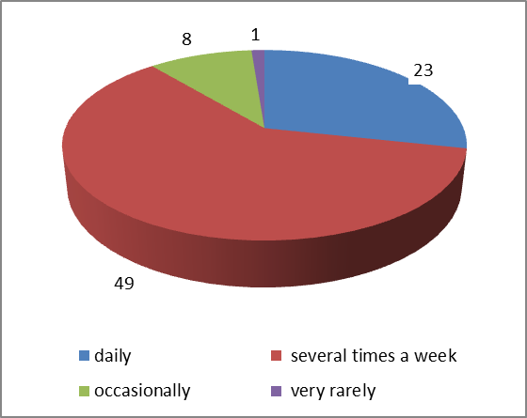

Fig. 1. …………………..

4. Conclusion

Conclusion section contains a few sentences at the end of the paper and concludes the results and discussions.
In conclusion we can remark ………..

5. Acknowledgments

Collate acknowledgements in a separate section at the end of the article before the references and do not, therefore, include them on the title page, as a footnote to the title or otherwise. List here those individuals who provided help during the research (e.g., writing assistance or proof reading the article, providing language help, etc.).

6. References

- REGA A., YARRI S., Consumer Perception and Attitudes, Journal, 3: 42–50, (2013)
- SPENCES M., Taste and Flavor Perception, Chemosensory Journal, 3: 69-84, (2012)

References - All references mentioned in the Reference list must be cited in the text, (in the format [1], [2], [3-6] and so on), and vice versa.
References should be presented in consecutive order (as they are cited in the text)

References should be presented in consecutive order (as they are cited in the text) and should follow the model: Author's First Name, Last Name (capitals letter), Title of book, Number of edition, nr.of tom, Name of Publishing House, place, year of publication, pages. The first six authors should be presented. References should be presented in English.

Web references: as a minimum, the full URL should be given and the date when the reference was last accessed. Any further information, if known (author names, dates, reference to a source publication, etc.), should also be given.

